Wicincila

omaskekiciye

society
  - Empowering & Investing
  - In Our Young Indigenous Girls
White Buffalo Calf Womans Society along with The Imagen Network would like to invite all young Indigenous girls Ages 10-19 to participate in Wicincila Omaskekiciye Society!  Wicincila Omaskekiciye Society is a culturally based program created to empower young Indigenous girls by building self-esteem, gaining knowledge on health and well-being along with leadership skills, communication, and relationship skills and so much more!  SIGN UP TODAY.!!! | 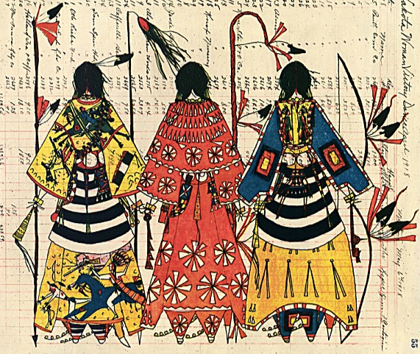

If you are near these two communities & would like to sign up, Please Contact the Person listed for your community…  Spring Creek : Gwendalyn Small Bear  Email: gwen@wbcws.org  Antelope : Sharisse Sitting Bear  Email: sharisse@wbcws.org | 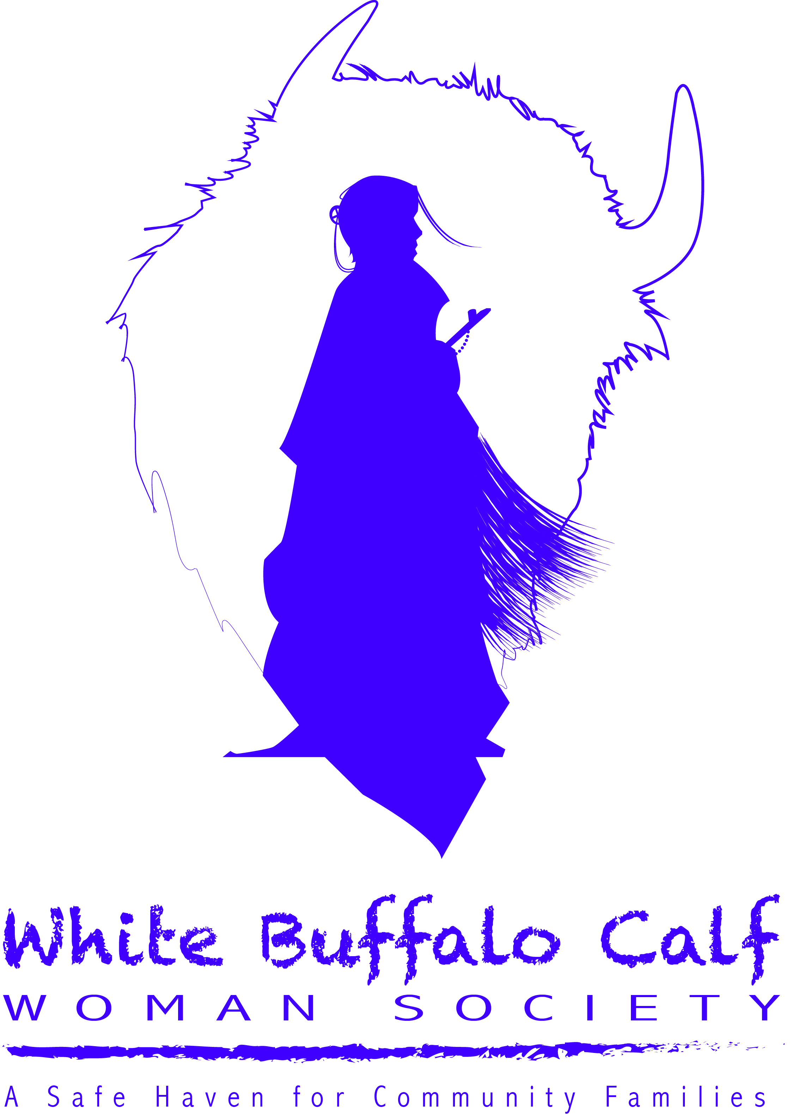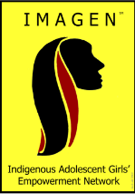

White Buffalo Calf Womans Society

Po Box 227 | Mission, SD 57555 | 605-856-2317 | www.wbcws.org

Additional directions or other information

